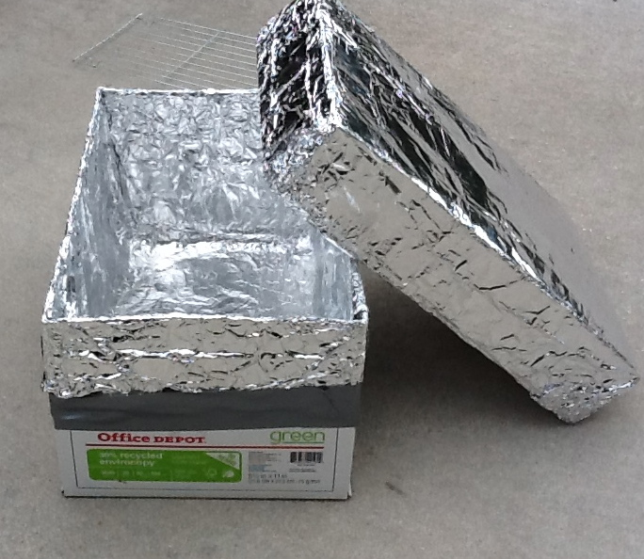
The Charcoal Reflector Oven
by Tom McCombs

Using a Charcoal Reflector Oven, I was able to generate 350-400 degrees using only 4 – 5 charcoal briquettes. I cooked a batch of dinner rolls and cinnamon rolls. It was very efficient compared to a 12 inch Dutch Oven requiring 24 briquettes to accomplish the same thing.

Here is what you will need:
- Standard box that holds reams of paper, 10 reams of 8 ½ by 11 inch paper (got mine at Office Depot).
- 2 metal pie plates (to hold the briquettes)
- Coat hanger used as a cooking rack (I used 4 pop cans)
- 2 Cooking racks
- Aluminum Foil

1. Line the box with aluminum foil. Some people use Elmer’s glue to hold it in place. I used duck tap around the outside of the box. Notice the slit in the side to allow air for the briquettes.

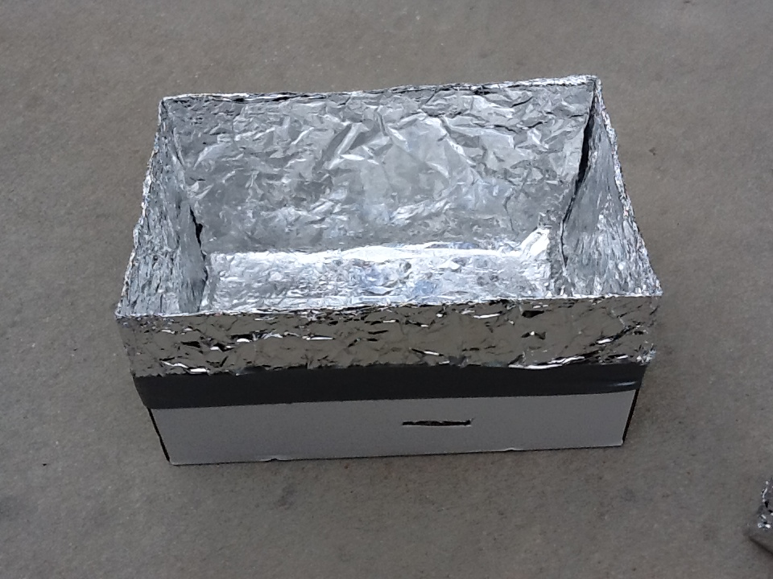

2. Cover the lid with aluminum foil both inside and out.

3. Place the 2 metal pie plates on a cooling rack in the bottom of the box. (I got two cooling racks at the dollar store for $1.00). You can use anything to raise the pie plates above the bottom of the box to prevent the bottom of the box from getting too hot.

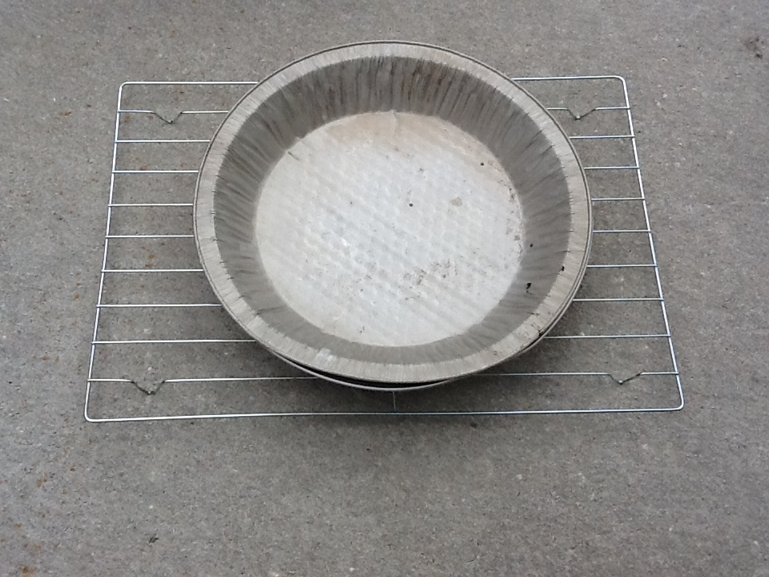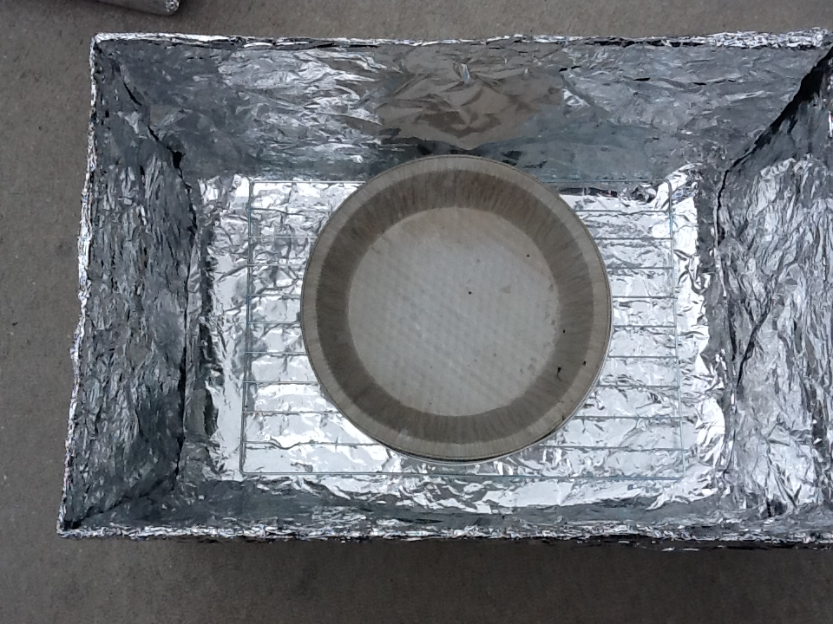

4. Make a rack to hold your cooking rack. I used 4 pop cans to try it out. Since I know the oven works, I will use some coat hangers or other wire pushed through the box to hold up my cooking rack.

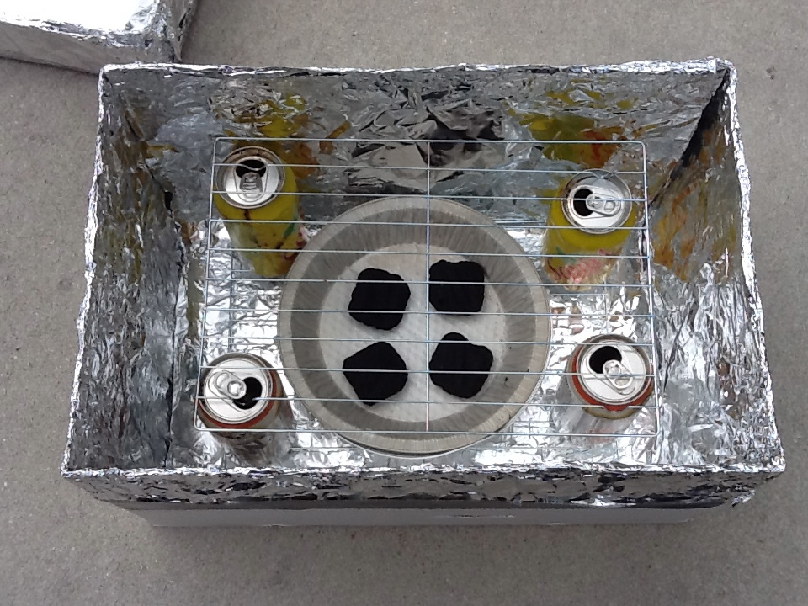

5. Light the briquettes in a briquette chimney. When the briquettes are mostly gray (about 20 min.), place them in the oven, add your food and cover the box.

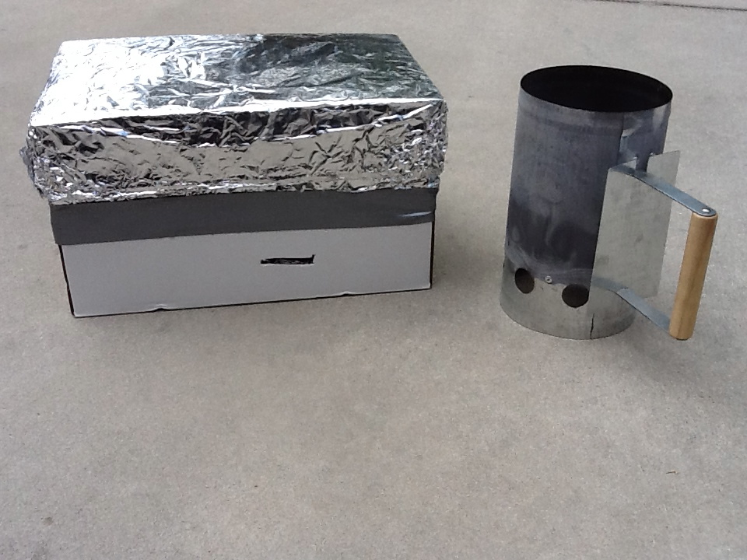

The following is research conducted by Sara McGuire and Prof. Steven E. Jones at BYU to find an alternative to solar cooking when the sun was not shining:

“The final area I researched was cooking alternatives when the sun is not shining and solar cookers cannot be used. One option I tested was a charcoal reflector oven. It is made out of a cardboard box that has been completely lined with aluminum foil. It has two holes (about 1-cm diameter) towards the bottom of the box, on both sides, to provide the air that is needed for the charcoal to burn. It also has two wires near the top to place a tray of food on. Finally there is a metal pie plate at the bottom, which is meant to hold the burning charcoal.

For my reflector oven tests I heated 6 charcoal briquettes using a chimney starter. I then added one charcoal at a time into the box. I measured the temperature within the box by placing a temperature probe inside it. I then compared the temperature in the box with the number of briquettes inside it. Articles on these ovens have said that each briquette adds 40°F. However, I found that the first briquette adds on average 123 °F/69°C, the second briquette adds 92°F/52°C, the third briquette adds 50 °F/28°C, the fourth briquette adds 36°F/20°C, the fifth briquette adds 30 °F/17°C, and the sixth briquette adds 20 °F/11°C. So as briquettes are added the amount that the temperature increases tends to fall off. The first two briquettes by far contribute the most heat.

I also conducted two other tests to see how well the charcoal reflector oven functions. First, I tested to see how fast it heats up. I placed four charcoal briquettes, which had already been heated for 20 minutes following lighting, into the charcoal oven. I then measured the time it took for the oven to reach its maximum temperature. I found that it took only 10 minutes for the charcoal reflector oven to heat up. The second test I performed was to see how well the charcoal reflector oven maintains its temperature. I conducted my test using four charcoal briquettes. I then measured the decrease in temperature over a three hour time period. I found that the temperature inside the oven decreased by over 100 ° F/60°C after one hour, more then 150°F/90°C after two hours, and over 200 ° F/120°C in three hours. With a blanket on top of the box-oven, the cooling rate would be less.” Solar Cookers and Other Cooking Alternatives

Dr. Jones reviews it here with his Solar Funnel Cooker:
http://www.youtube.com/watch?v=2dT6kY54zrM&feature=related

